1.4 Arc Length Worksheet

- Find the exact arc length of the curve over the given interval: from to .
- Set up, but do not evaluate, an integral with respect to x.
We note that which is continuous from to .
Therefore the arc length is given by:
We do not yet have the ability to evaluate such an integral. More advance integration techniques in Ch. 2 will allow us to do so.

- Set up, but do not evaluate, an integral with respect to y.
We must solve the equation for x. .
We note that , therefore we are interested in the arc length of from to
We also note that is continuous from to .
Therefore the arc length is given by:
- Determine the length of between .
(Hint: Although we have not shown this in class yet it is true that )

We see that which is continuous for .
Therefore the arc length of the curve is given by:
We then have . Since we know that and therefore . So we have:

- Setup, but do not evaluate, an integral which represents the length of the curve on .

We note that is NOT continuous on and therefore we cannot set up this integral with respect to x. We instead will set the integral up with respect to y.
on .
We note that is continuous on .
Therefore, the arc length is given by .

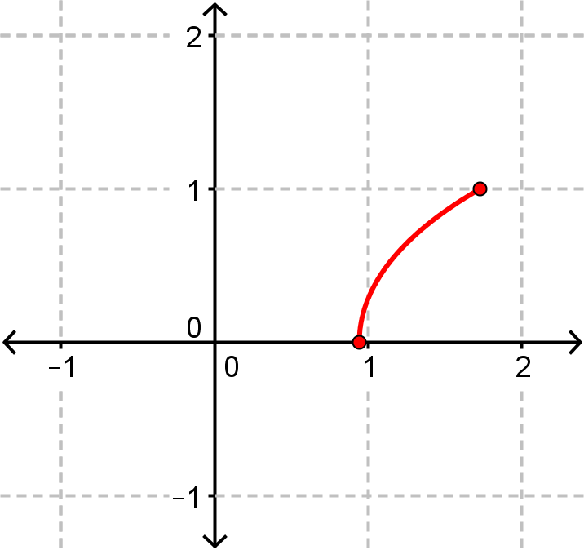
- Find the exact arc length of the curve over the given interval. from to .
is continuous on .

- Find the exact arc length of the curve over the given interval. from to .
We note that .
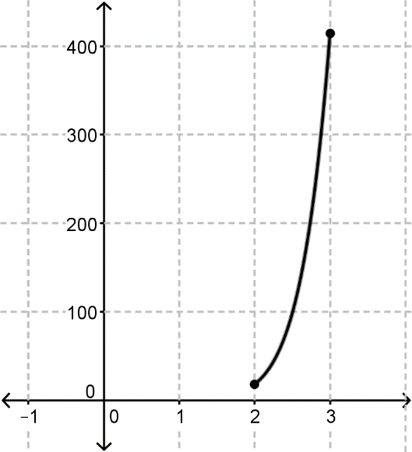
So is continuous on .

- Kyle is setting up an integral with respect to y which is supposed to find the arc length of the curve on . He sets up the following integral with respect to y
Kyle’s professor tells him that his integral isn’t guarantted to represent the arc length. Why is this?

The issue here is is not continuous at on , specifically at .
Since the conditions for the arc length formula are not met, we cannot guarantee that this integral represents the arc length of on .

- Find the exact arc length of from to .
We note that . So, is continuous on .
Therefore,
We can see that is positive for all values on , so we can drop the absolute value bars.

- Find the exact arc length of from to .
We note that is continuous on .
Therefore,
We proceed with a u-sub. Let and this implies
Our bounds become .

